**NetMedEx: Hybrid Graph-Guided Retrieval-Augmented Conversational Exploration of Biomedical Literature**

Shu-Hwa Chen1, Zheng-Xiang Ye2, Min-Der Lin 3,4,5, Chung-Yen Lin2,6,7*

1 TMU Research Center of Cancer Translational Medicine, Taipei Medical University, 250 Wu-Xing Street, Taipei, 11031, Taiwan

2 Genome and Systems Biology Degree Program, National Taiwan University and Academia Sinica, Taipei 10617, Taiwan

3 Institute of Medical Sciences, Tzu Chi University, 701 Zhongyang Rd., Sec. 3, Hualien, 97004, Taiwan

4 Center for Herbal Medicine and Natural Products Research, Tzu Chi University, Hualien 970004, Taiwan

5 Department of Molecular Biology and Human Genetics, Tzu Chi University, 701 Zhongyang Rd., Sec. 3, Hualien, 97004, Taiwan

6 Institute of Information Science, Academia Sinica, Taipei 115, Taiwan

7 Institute of Fisheries Science, National Taiwan University, Taipei 10617, Taiwan

**Abstract**

Identifying biological concepts relevant to a specific research interest, such as genes, chemicals, and diseases, is essential for a comprehensive understanding of existing knowledge and emerging research trends. However, the relationships among these concepts are often scattered across numerous publications. To simplify the exploration of related publications and more effectively integrate relevant biological concepts, we developed **NetMedEx**, a comprehensive tool available as a Docker image that can be downloaded and executed locally. This tool constructs interactive networks of biological concepts extracted from more than 30 million PubMed articles using PubTator3.

A key advancement in this work is the integration of an interactive Chat Panel powered by Hybrid Retrieval-Augmented Generation (Hybrid RAG), which enables researchers to converse directly with the extracted data. Unlike standard RAG, which only retrieves text, our Hybrid approach simultaneously retrieves unstructured semantic context (via vector search of PubMed abstracts) and structured topological context (via graph algorithms such as shortest paths and community detection). This synergy transforms static network analysis into a dynamic dialogue, where users can interrogate subgraphs, ask questions about specific mechanisms, and receive answers grounded in both AI-synthesized evidence and validated network paths.

As a case study, we applied NetMedEx to investigate the potential therapeutic mechanisms of herbal drugs for osteoporosis, with a specific focus on the regulatory roles of microRNAs (miRNAs). We retrieved a targeted collection of articles and generated a co-mention network that highlighted complex interactions between herbal compounds, specific miRNAs, and osteogenic pathways. The network analysis, refined by our Hybrid RAG system, successfully identified valid mechanistic hypotheses linking herbal interventions to bone density regulation via miRNA-mediated signaling. Finally, we demonstrated that NetMedEx facilitates efficient literature exploration and the analysis of complex biological relationships. NetMedEx is freely available at <https://github.com/lsbnb/NetMedEx>.

**Keywords:** Biomedical Text Mining; Network Medicine; Hybrid Retrieval-Augmented Generation (RAG); Large Language Models (LLMs); PubTator3; Knowledge Graph; Osteoporosis; MicroRNAs (miRNAs); Herbal Medicine; Knowledge Discovery

**Highlights:**

* **Graph-Guided Conversational Discovery**: Features a **Hybrid RAG Chat Panel** that synergizes vector-based text retrieval with graph-based topological reasoning, enabling researchers to **directly converse with biomedical data** to uncover mechanisms behind complex relationships.
* **Targeted Knowledge Extraction**: Constructs interactive co-mention networks from over 30 million PubMed articles, allowing for the precise identification of **genes, diseases, chemicals, and species** relevant to specific research topics like Osteoporosis and Herbal Medicine.
* **Reproducible & Scalable Deployment**: Delivered as a fully containerized **Docker** image for seamless local execution, ensuring consistent performance for high-throughput literature mining and hypothesis generation.

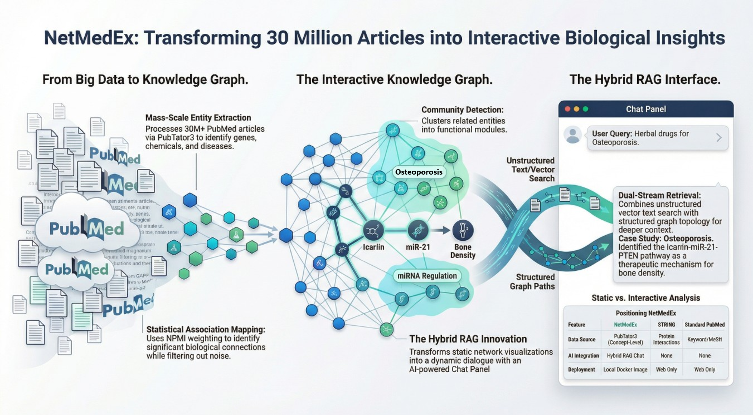

# Introduction

Identifying associations between biomedical concepts, including genes, chemicals, and diseases, is crucial for developing treatments, studying off-target and synergistic effects, and understanding the drugs. Such associations can be confirmed through experimental data and collectively via manual literature review or mining with relation extraction (RE) techniques. A recent work, PubTator3, utilized their state-of-the-art machine learning models to perform named entity recognition (NER) and RE across millions of PubMed abstracts and full-text PMC articles (Wei et al., 2024; Wei et al., 2019). These annotations are accessible via their website and application programming interface (API), enabling easier access for the research community. Users can search for biological concepts of interest and retrieve annotations from the relevant articles. While presenting all relevant articles provides comprehensive information, developing methods to extract and summarize key biological concepts could help users quickly identify the most pertinent details for their query, reducing the effort required for manual review.

Therefore, we developed NetMedEx, a tool that applies a co-mention-based method to summarize biological concepts in research articles into an interactive graph. NetMedEx constructs a network by analyzing the strength of co-occurrence between genes, chemicals, diseases, and other biological entities and then clusters them into communities. The resulting network helps users pinpoint key biological concepts and filter relevant articles. We also provide functionalities to navigate and view the network at different levels of detail.

# Methods

**Data retrieval**

NetMedEx leverages the PubTator3 API (Wei et al., 2024) to retrieve over 30 million PubMed abstracts and over 6 million full-text articles annotated with biomedical concepts. Users can input a text query of biological terms or provide one or more PubMed reference numbers (PMID) to specify relevant articles. The retrieved articles are processed through a pipeline consisting of text normalization, co-occurrence matrix calculation, and network construction (Figure 1).

**Text normalization**

NetMedEx extracts only the biological concept annotations from a PubTator file generated by PubTator3 and discards all other text. A biological concept annotation includes the original text, the entity type (e.g., gene, chemical, disease, and species), and a Medical Subject Headings (MeSH) identifier when available. The original text of each annotation is normalized to avoid synonyms that refer to the same biological concepts. If an annotation has a known MeSH term, the original text is replaced with the standardized MeSH term. If no MeSH term is available, a conservative plural stemmer is applied (Harman, 1991), and the text is converted to lowercase to maintain consistency across terms.

**Co-occurrence matrix calculation**

Duplicate annotations within the same article are removed, leaving a unique set of terms for each article. A co-occurrence matrix is then constructed by counting the number of times any two normalized terms co-appear within the same article. Only non-zero counts are stored to conserve memory. In addition, the document frequency of each term is calculated for use in later weighting adjustments.

**Network construction**

A co-occurrence network is built by representing each unique term as a node and the co-occurrence counts between two terms as edge weights. The strength of the relationship between two terms increases with the frequency of their co-occurrence within the same article. However, co-occurrence alone does not necessarily imply contextual or causal relationships. To adjust for this, NetMedEx provides two options for calculating edge weights:

1. Frequency-based method (Eq. 1):

|  |  |
| --- | --- |
| $$w_{ij}=\frac{a_{ij}}{\max_{i, j}{{(a}_{ij})}}$$ | (1) |

1. Normalized Pointwise Mutual Information-based (NPMI) method (Eq. 2):

|  |  |
| --- | --- |
| $$w_{ij}=\frac{\log_{2}{[p(i)p(j)]}}{\log_{2}{p(i, j)}} - 1$$ | (2) |

where $a_{ij}$ is the raw co-occurrence count between terms $i$ and $j$, $p(i)$ and $p(j)$ are the document frequencies of terms $i$ and $j$, respectively, and $p(i, j) = \frac{a_{ij}}{N}$, where *N* is the total number of articles. The scaled edge weight $w_{ij}$ ranges from of 0 to 1 for the frequency-based method and from -1 to 1 for the NPMI-based method. Edges with weights below a user-defined threshold are pruned to simplify the network. Isolated nodes that result from pruning are also removed.

**Community Detection**

To identify clusters of related terms, NetMedEx applies the Louvain method (Blondel et al., 2008), which optimizes the network's modularity to detect non-overlapping communities. Edges between communities are combined into a single representative edge. The node with the highest degree in each community is selected as the representative term for that cluster. This clustering simplifies the network structure while preserving key relationships among highly connected terms.

**Implementation**

NetMedEx is implemented in Python and provides a command-line interface (CLI) and a web interface. The CLI enables streamlined execution of tasks, while the web interface includes interactive and exploratory analysis features. NetMedEx’s web interface allows users to search for biomedical terms, adjust filters and weighting criteria, and download article abstracts, annotations, and generated networks for further analysis (Figure 2). Users can also click on edges to access detailed information of the supporting articles. The NetMedEx source code and usage guidelines are available at <https://github.com/lsbnb/NetMedEx>.

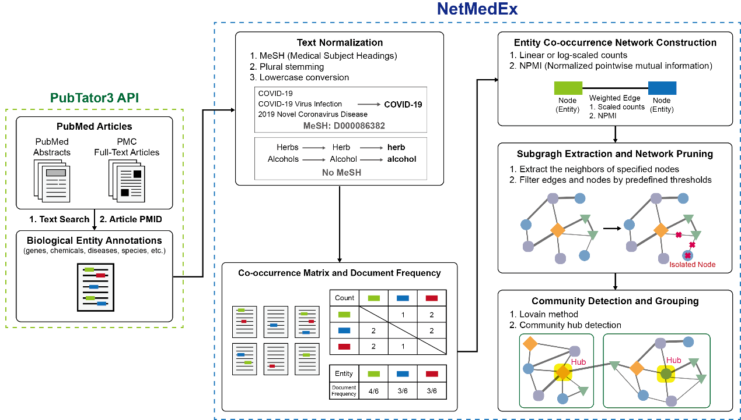

Figure 1. Workflow of NetMedEx for generating co-mention networks for biomedical concepts.

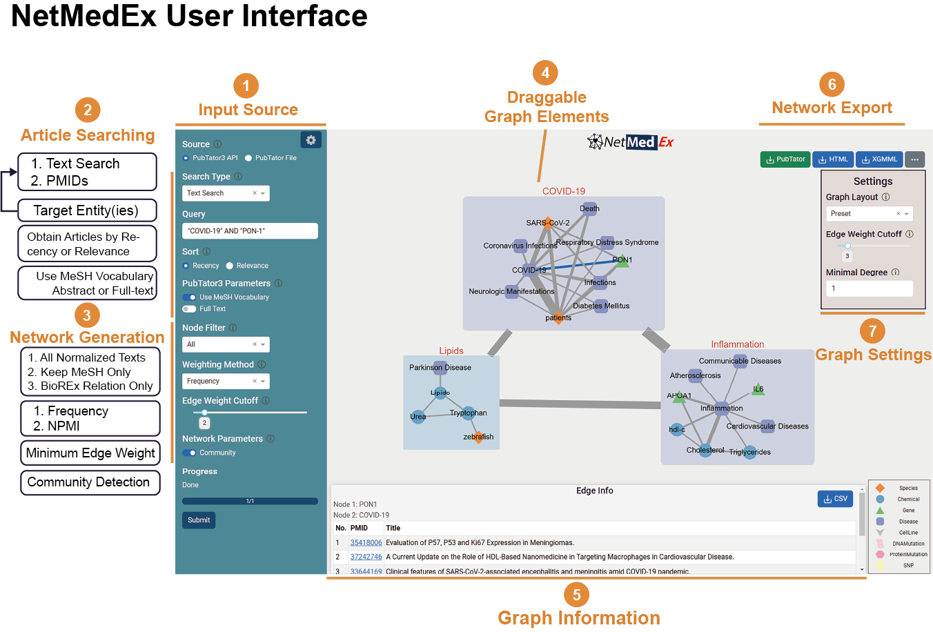

Figure 2. NetMedEx web interface.

1. Networks can be generated end-to-end from either article searches or manually uploaded PubTator files.

2. Users can enter text queries to retrieve all relevant articles or specify PMIDs to collect selected articles only.

3. Networks can be filtered by criteria such as node type (e.g. MeSH terms only or high-confident relationships annotated by PubTator3) and weighting method (frequency or NPMI).

4. All elements in the graph are draggable. Communities are enclosed in colored boxes. The node with the highest degree is marked as the hub for each community.

5. Users can view supporting evidence by clicking on a graph element.

6. Generated networks can be exported as interactive HTML files or as XGMML files compatible with Cytoscape.

7. Graph layout, edge weight cutoffs, and minimal node degree can be adjusted after the network is generated for further customization.

**Methods: Graph-Guided Retrieval-Augmented Generation**

**2.X Graph-Guided Retrieval-Augmented Generation**

NetMedEx integrates graph-based filtering with retrieval-augmented generation (RAG) to enable evidence-grounded conversational exploration of biomedical literature. Rather than applying conversational models directly to the entire corpus, NetMedEx constrains retrieval and generation through an intermediate semantic network constructed from named entities and their relationships.

**2.X.1 Edge-Guided Literature Selection**

Following network construction, users interactively select one or more edges of interest within the graph visualization. Each edge represents a relationship between two biomedical entities and is associated with one or more PubMed identifiers (PMIDs) corresponding to source articles. The selected edges define a focused subgraph, from which the union of associated PMIDs is extracted.

This edge-guided selection step serves as an explicit user-driven filter that narrows the literature scope prior to conversational analysis, ensuring that subsequent retrieval is limited to conceptually relevant documents.

**2.X.2 Abstract Retrieval and Preprocessing**

For each selected PMID, the corresponding abstract text is retrieved from a locally cached corpus or via standardized bibliographic sources. Abstracts are deduplicated and normalized, and metadata such as publication year and entity mentions are retained for downstream reference and citation.

Only abstracts explicitly linked to user-selected edges are included in the conversational knowledge base, preventing the inclusion of unrelated documents.

**2.X.3 Vector Index Construction**

The retrieved abstracts are embedded into a vector representation using configurable embedding models. NetMedEx supports both remote and local embedding backends, allowing users to balance performance, cost, and privacy considerations. The resulting embeddings are stored in a vector database, enabling efficient similarity-based retrieval.

This vector index is constructed dynamically based on the selected subgraph, ensuring that the conversational context remains tightly coupled to the graph exploration process.

**2.X.4 Conversational Retrieval and Answer Generation**

When a user submits a natural language query, the system performs similarity-based retrieval over the vector index to identify the most relevant abstracts. Retrieved documents are then supplied to a language model as contextual evidence for answer generation.

All generated responses are conditioned exclusively on the retrieved abstracts and are required to include explicit references to the supporting PMIDs. The system does not generate answers in the absence of retrieved evidence, thereby enforcing grounding in the source literature.

**2.X.5 Provenance Tracking and Citation**

Each conversational response includes a list of PMIDs corresponding to the abstracts used during retrieval. This provenance information enables users to trace statements back to their original sources and supports manual verification of generated content.

By integrating graph-guided filtering, retrieval-based grounding, and explicit citation, NetMedEx provides a controlled conversational interface for literature exploration that complements traditional network analysis.

2️⃣ **System Overview Figure Caption**

Figure X. System overview of NetMedEx and graph-guided conversational exploration.

NetMedEx implements an end-to-end Search → Graph → Chat workflow for biomedical literature mining. PubMed abstracts are first processed using named entity recognition (NER) and relationship extraction to construct an interactive semantic network of biomedical entities. Users explore this network and select edges of interest, which define a focused subgraph and associated PubMed articles. Abstracts linked to the selected edges are retrieved and embedded to form a dynamic vector index. A retrieval-augmented generation (RAG) module then enables conversational querying over the selected literature, with all responses grounded in retrieved abstracts and accompanied by explicit PMID citations. This architecture integrates graph-based filtering, semantic retrieval, and evidence-aware natural language interaction within a unified analytical framework.

3️⃣ **Conversational AI Safety and Grounding**

**Conversational AI Safety and Grounding**

NetMedEx is designed to support exploratory analysis of biomedical literature while minimizing risks associated with ungrounded or misleading language model outputs. The conversational component operates under strict grounding constraints and does not function as a free-form generative chatbot.

First, conversational retrieval is explicitly limited to abstracts associated with user-selected graph edges. This graph-guided filtering prevents the inclusion of irrelevant or unrelated documents and ensures that the conversational context reflects user-defined analytical intent.

Second, all responses are generated using a retrieval-augmented generation framework, in which language model outputs are conditioned solely on retrieved abstracts. If no relevant documents are retrieved, the system refrains from generating an answer.

Third, NetMedEx enforces provenance transparency by requiring all responses to include explicit PMID citations corresponding to the supporting abstracts. This design enables users to verify statements against the original literature and discourages speculative or unsupported claims.

Finally, NetMedEx is intended for research exploration and hypothesis generation rather than clinical decision-making. The system does not produce novel biomedical assertions, diagnostic recommendations, or treatment guidance. Users are encouraged to interpret conversational outputs as literature summaries rather than authoritative conclusions.

**Results**

**Case Study**

We tested NetMedEx’s capability to summarize over 100 articles using “Chuan Mu Tong” as a query (Figure 3A). The results show that *Clematis armandii*, the scientific name for Chuan Mu Tong, is linked to “lignans,” highlighting studies on the roles of lignans in Chuan Mu Tong (Pan et al., 2017). Lignans are also connected to “inflammation”, with related studies suggesting an anti-neuroinflammatory effect of Chuan Mu Tong (Xiong et al., 2014). This demonstrates how NetMedEx helps users quickly identify relevant articles, greatly reducing the time and effort needed to review all content.

Expanding our investigation, we queried “Osteoporosis AND Lignans” and obtained approximately 1000 articles. The resulting network, shown in Figure 3B, revealed frequent co-mentions of lignans and flavonoids in osteoporosis-related studies. A review of these articles identified research on active compounds in treating osteoclast-mediated bone-destructive diseases (An et al., 2016; Xu et al., 2022; Zhang et al., 2016);. Furthermore, studies discussing the estrogenic effects of lignans and flavonoids in reducing osteoporosis risk were also identified (Gorzkiewicz et al., 2021; Rietjens et al., 2017; Zhao et al., 2017). Thus, NetMedEx facilitates uncovering connections between diverse topics that have yet to be fully explored together.

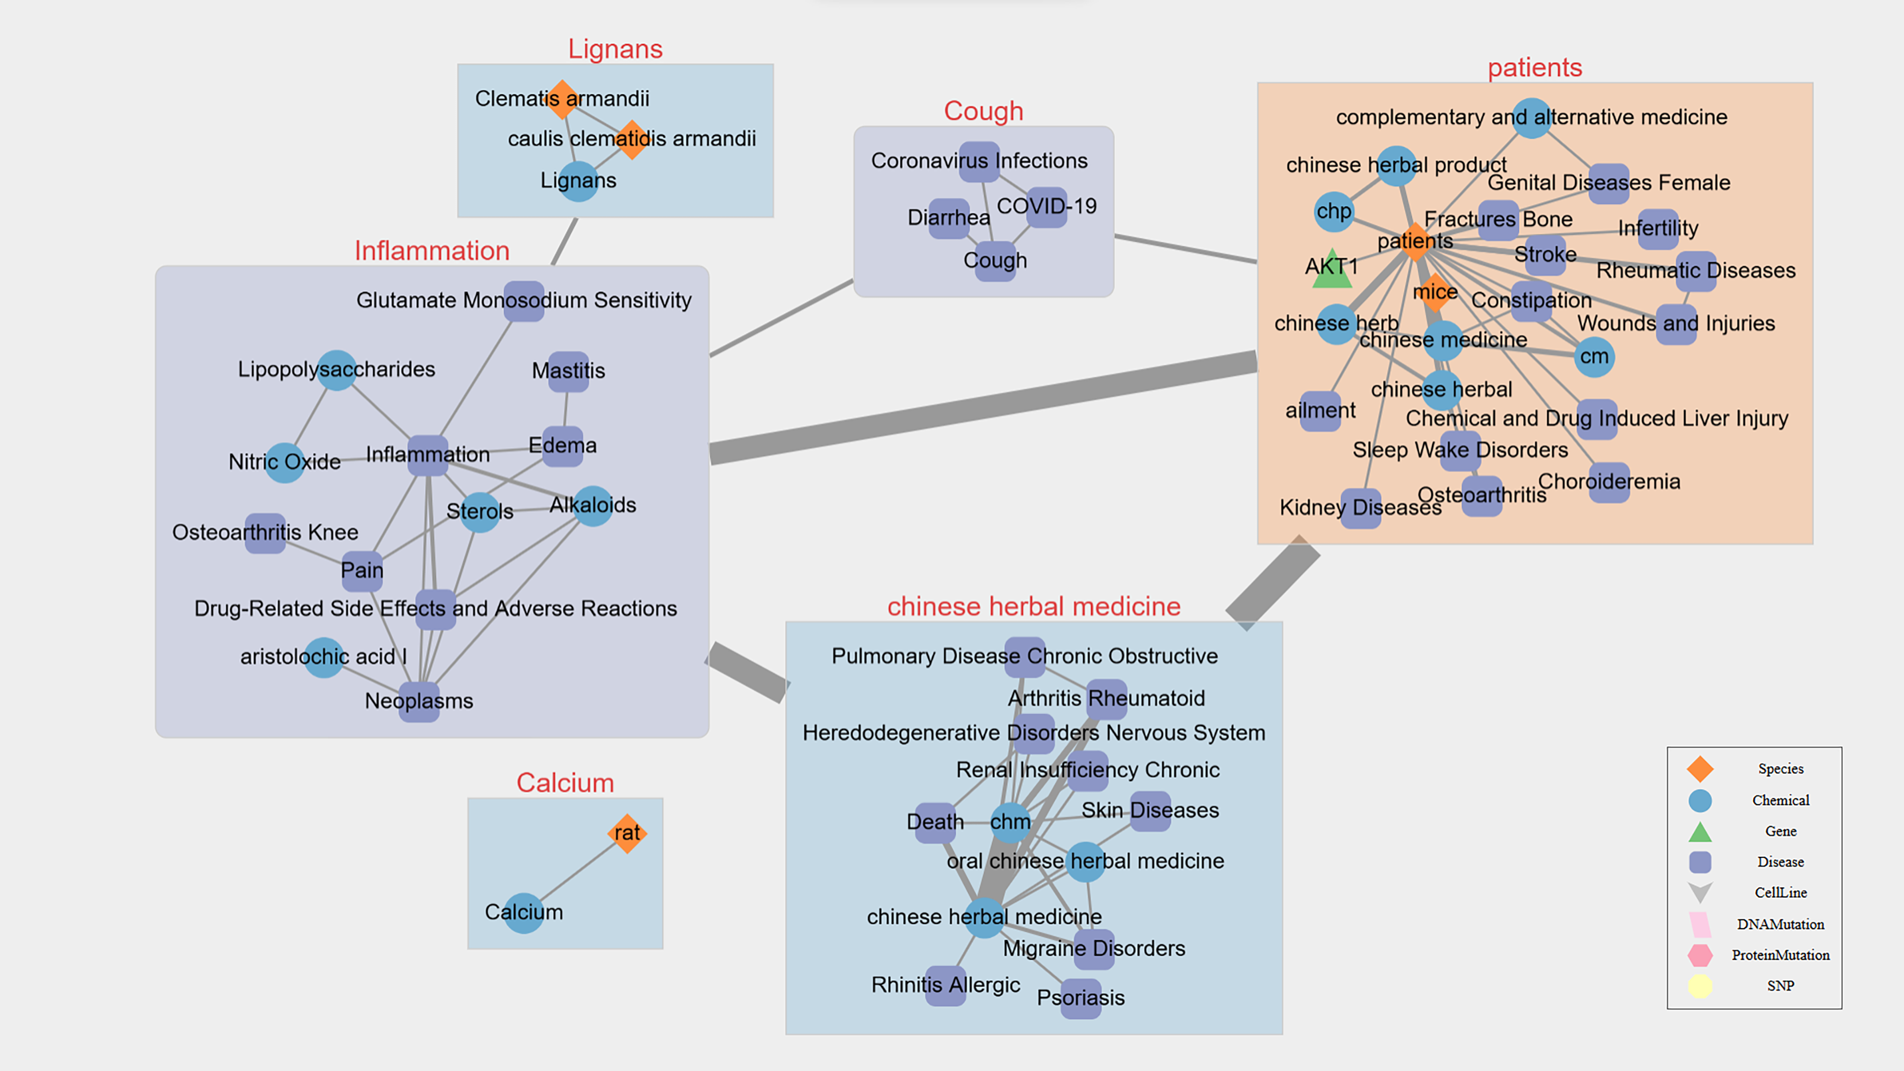

**(A)**

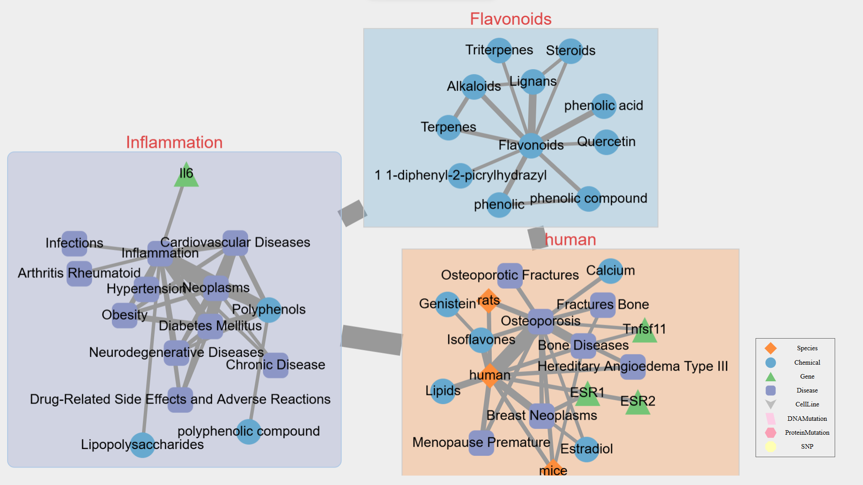

**(B)**

Figure 3. Co-mention networks generated by NetMedEx.  
(A) “Chuan Mu Tong” (105 PubMed abstracts). (B) “Osteoporosis AND Lignans” (most recent 1000 PubMed abstracts from 1084 articles).

**Limitations and Ethical Considerations**

**Limitations**

First, the semantic relationship extraction in NetMedEx relies on large language models, which may occasionally produce incomplete or inconsistent outputs due to variability in model responses or ambiguous language in abstracts. To mitigate this risk, NetMedEx restricts analysis to explicitly stated relationships, requires supporting evidence sentences, and applies user-defined confidence thresholds to filter low-certainty predictions.

Second, semantic analysis is performed at the abstract level and does not incorporate full-text articles, supplementary materials, or figures. As a result, some relationships described outside abstracts may not be captured.

Third, confidence scores assigned by the LLM represent model-estimated certainty rather than calibrated probabilities and should be interpreted comparatively rather than as absolute measures.

Finally, while semantic extraction improves precision over co-occurrence–based methods, it does not replace expert curation. Curated resources such as BioREx remain essential for high-confidence knowledge integration.

**Ethical Considerations**

NetMedEx does not generate novel biomedical claims or clinical recommendations. All extracted relationships are directly grounded in published literature, and evidence sentences are preserved to enable human verification. The system is intended for exploratory literature analysis and hypothesis generation rather than clinical decision-making.

When using external LLM services, users are responsible for complying with relevant data usage and privacy policies. NetMedEx processes only publicly available bibliographic text and does not require the input of personal or sensitive patient data.

# Future Directions

NetMedEx builds networks using co-mention-based relationships between biological concepts. This method is computationally efficient and does not require prior knowledge of the retrieved articles. However, this approach may connect unrelated concepts together simply because they appear in the same article. Although we developed frequency-based and NPMI-based methods to prune these relationships, this does not guarantee that only edges between unrelated concepts are removed.

Transformer-based relation extraction on biomedical literature has been explored in previous works (Lai et al., 2023; Phan et al., 2021). These models tend to be more adaptable to dataset changes across various tasks than traditional machine learning models (Milosevic & Thielemann, 2023). By accurately capturing the context underlying relationships between biological concepts, these models enable more precise reasoning over the graph and interpretation of the connections.

Therefore, alongside the co-mention-based method to obtain graphs rapidly, we aim to explore more accurate representations of relationships leveraging large language models (LLMs), providing users with options to retrieve precise connections between biological concepts of interest.

# References

An, J., Hao, D., Zhang, Q., Chen, B., Zhang, R., Wang, Y., & Yang, H. (2016). Natural products for treatment of bone erosive diseases: The effects and mechanisms on inhibiting osteoclastogenesis and bone resorption. *International immunopharmacology*, *36*, 118–131.

Blondel, V. D., Guillaume, J. L., Lambiotte, R., & Lefebvre, E. (2008). Fast unfolding of communities in large networks. *Journal of Statistical Mechanics-Theory and Experiment*, Article P10008. <https://doi.org/10.1088/1742-5468/2008/10/p10008>

Gorzkiewicz, J., Bartosz, G., & Sadowska-Bartosz, I. (2021). The potential effects of phytoestrogens: The role in neuroprotection. *Molecules*, *26*(10), 2954.

Harman, D. (1991). HOW EFFECTIVE IS SUFFIXING. *Journal of the American Society for Information Science*, *42*(1), 7–15. <https://doi.org/10.1002/(sici)1097-4571(199101)42:1>

Lai, P. T., Wei, C. H., Luo, L., Chen, Q. Y., & Lu, Z. Y. (2023). BioREx: Improving biomedical relation extraction by leveraging heterogeneous datasets. *Journal of Biomedical Informatics*, *146*, Article 104487. <https://doi.org/10.1016/j.jbi.2023.104487>

Milosevic, N., & Thielemann, W. (2023). Comparison of biomedical relationship extraction methods and models for knowledge graph creation. *Journal of Web Semantics*, *75*, Article 100756. <https://doi.org/10.1016/j.websem.2022.100756>

Pan, L.-L., Wang, X.-L., Luo, X.-L., Liu, S.-Y., Xu, P., Hu, J.-F., & Liu, X.-H. (2017). Boehmenan, a lignan from the Chinese medicinal plant Clematis armandii, inhibits A431 cell growth via blocking p70S6/S6 kinase pathway. *Integrative Cancer Therapies*, *16*(3), 351–359.

Phan, L. N., Anibal, J. T., Tran, H., Chanana, S., Bahadroglu, E., Peltekian, A., & Altan-Bonnet, G. (2021). Scifive: a text-to-text transformer model for biomedical literature. *arXiv preprint arXiv:2106.03598*.

Rietjens, I. M., Louisse, J., & Beekmann, K. (2017). The potential health effects of dietary phytoestrogens. *British journal of pharmacology*, *174*(11), 1263–1280.

Wei, C. H., Allot, A., Lai, P. T., Leaman, R., Tian, S. B., Luo, L., Jin, Q., Wang, Z. Z., Chen, Q. Y., & Lu, Z. Y. (2024). PubTator 3.0: an AI-powered literature resource for unlocking biomedical knowledge. *Nucleic Acids Research*, *52*(W1), W540–W546. <https://doi.org/10.1093/nar/gkae235>

Wei, C. H., Allot, A., Leaman, R., & Lu, Z. Y. (2019). PubTator central: automated concept annotation for biomedical full text articles. *Nucleic Acids Research*, *47*(W1), W587–W593. <https://doi.org/10.1093/nar/gkz389>

Xiong, J., Bui, V.-B., Liu, X.-H., Hong, Z.-L., Yang, G.-X., & Hu, J.-F. (2014). Lignans from the stems of Clematis armandii (“Chuan-Mu-Tong”) and their anti-neuroinflammatory activities. *Journal of ethnopharmacology*, *153*(3), 737–743.

Xu, Q., Cao, Z., Xu, J., Dai, M., Zhang, B., Lai, Q., & Liu, X. (2022). Effects and mechanisms of natural plant active compounds for the treatment of osteoclast-mediated bone destructive diseases. *Journal of Drug Targeting*, *30*(4), 394–412.

Zhang, N.-D., Han, T., Huang, B.-K., Rahman, K., Jiang, Y.-P., Xu, H.-T., Qin, L.-P., Xin, H.-L., Zhang, Q.-Y., & Li, Y.-m. (2016). Traditional Chinese medicine formulas for the treatment of osteoporosis: implication for antiosteoporotic drug discovery. *Journal of ethnopharmacology*, *189*, 61–80.

Zhao, Y., Zheng, H.-X., Xu, Y., & Lin, N. (2017). Research progress in phytoestrogens of traditional Chinese medicine. *Zhongguo Zhong yao za zhi= Zhongguo Zhongyao Zazhi= China Journal of Chinese Materia Medica*, *42*(18), 3474–3487.